WEEK 4.1
AIM:To determine whether a given integer array contains any duplicate elements.
If any value appears more than once, return true; otherwise, return false.

ALGORITHM :
- Start
- Create an empty HashSet to store integers.
- Traverse each element in the given array nums.
- For each element:
  - If the element is already present in the HashSet,
return true (duplicate found).
  - Otherwise, add the element to the HashSet.
- If the traversal completes without finding duplicates,
return false.
- Stop
Program:
import java.util.*;
public class Solution {
static int[] compareTriplets(int[] a, int[] b) {
int aliceScore = 0;
int bobScore = 0;
for (int i = 0; i < 3; i++) {
if (a[i] > b[i]) {
aliceScore++;
} else if (a[i] < b[i]) {
bobScore++;
}
}
return new int[] { aliceScore, bobScore };
}
public static void main(String[] args) {
Scanner sc = new Scanner(System.in);
int[] a = new int[3];
int[] b = new int[3];
for (int i = 0; i < 3; i++) {
a[i] = sc.nextInt();
}
for (int i = 0; i < 3; i++) {
b[i] = sc.nextInt();
}
int[] result = compareTriplets(a, b);
System.out.println(result[0] + " " + result[1]);
}
}
Output:
5 6 7
3 6 10
1 1

Result:Thus the implementation of the triplets was executed successfully and executed successfully and output was verified.
Aim:
To determine whether a given integer array contains any duplicate elements.
If any value appears more than once, return true; otherwise, return false.
Algorithm :
- Start
- Create an empty HashSet to store integers.
- Traverse each element in the given array nums.
- For each element:
  - If the element is already present in the HashSet,
return true (duplicate found).
  - Otherwise, add the element to the HashSet.
- If the traversal completes without finding duplicates,
return false.
- Stop
Program:
import java.util.HashSet;
class Solution {
public boolean containsDuplicate(int[] nums) {
HashSet<Integer> set = new HashSet<>();
for (int num : nums) {
if (set.contains(num)) {
return true; }
set.add(num);
}
return false;
}
}

Output:
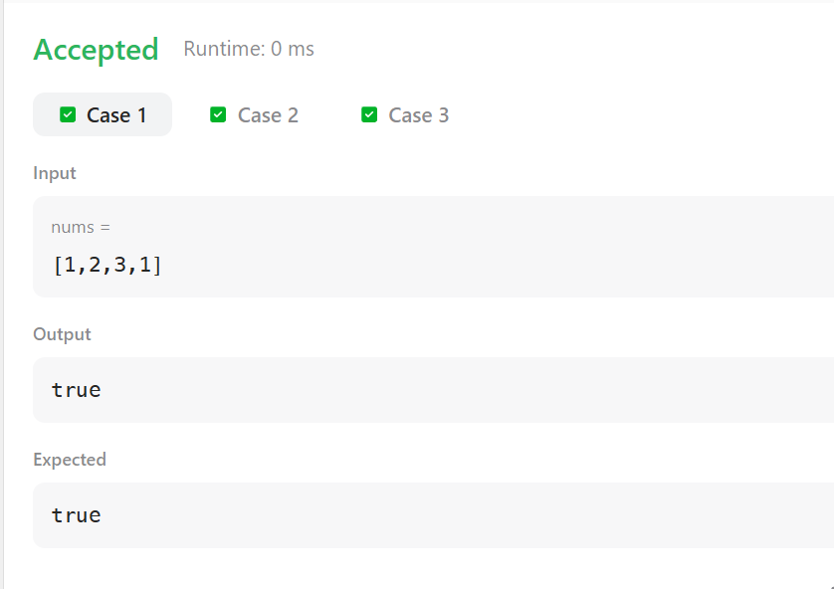

Result:
Thus the implementation of the duplicates was executed successfully and output has been verified successfully .

